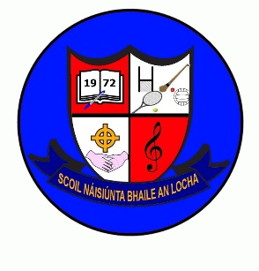
Newsletter February/March 2024
Confirmation Ceremony
March 7th @ 3pm in Kilskyre. There will be no school for 5th class on this day.
Photographer
Memory Lane photographer will be with us on Monday 11th March.
Sport
- We will be taking part in a chess tournament on 22nd February in Clonmellon.
- Hurling coaching will also commence in March.
- Swimming is organised for 2nd-6th Class after Easter. Details will follow after mid-term break.
Student Teacher
Eimear McDonnell will complete her placement for teacher training in 5th & 6th Class in Feb/Mar. We also have a TY student on work experience every Friday.
Staff Meeting
Takes place on March 6th. All students will finish @ 12.30 on this day to facilitate a staff meeting.
Deposit Return Scheme
We would be grateful if you could send in any clean undamaged bottles/cans with the re-turn logo. We can return these to the supermarket and get the deposit back for school funds.
First Communion
- First Confession will take place in school in April.
- First Communion takes place on Saturday 18th May @ 12.30

Important Dates
- Mid-term break school closed next week Mon 12th-16th February
- Feb 22nd nurses will call to our school for Junior Infant hearing and vision screening they will also screen new pupils in senior infants.
- 12th -19th March Bookfair. The school will get a percentage of money raised from book sales
- Friday 15th March wear green clothes to school
- 8th March school closed as we will be a polling station for the upcoming referendums
- 18th March school closed for St Patricks Day Bank Holiday
- 22nd March Easter Holidays @ 12noon reopen 8th April.
- School Hot Meals begin at the end of April. We will be in touch nearer the time with details.

Have an enjoyable mid-term break

