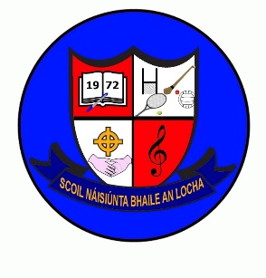
Newsletter November 2023
Welcome
We welcome Mrs Debbie Lynch to the staff. Mrs Lynch will be teaching 2nd,3rd & 4th class. We hope she will be very happy here in Ballinlough NS.
We welcome new pupils Oleh, Edijus, Evija and Sviatoslav. We hope they enjoy their time here in Ballinlough NS.
Finally welcome to our new Parents Association Committee; Lorna, Kathy, Celena and Joanne. Thank you, ladies, for agreeing to serve on this committee.
Congratulations to Mrs Sherwin on her appointment to Deputy Principal.
Healthy Eating Policy
We would like to draw you attention to the school’s Healthy Eating Policy which you will find on the school website: www.ballinloughns.com We would be grateful if you could adhere to this policy when making school lunches.
School Fees: were due before Halloween break. There are still a small number of outstanding fees. We would be grateful if you could forward payment at your earliest convenience.
Clothing/Uniform
As the weather has turned colder, please make sure your child has a warm coat. A number of children have come to school this week either without a coat or only wearing a light gilet. A good warm waterproof coat should be worn during the winter months and no shorts until the summer months please.
Christmas Cards: Templates have been distributed. These will be €10 per pack of 12 cards. Due in Monday 20th November. Also, Christmas annuals last day for orders Monday 20th November.

Important Dates
- Monday Dec 4th: School will be closed as teachers have to attend training in the New Maths Curriculum in Navan Education Centre on this day.
- Wednesday Dec 13th: Christmas Celebration will be held in the Church @ 7pm. All welcome.
- Thursday 21st Dec: School Fundraiser “Christmas Movie Afternoon” this will take place after school 2.40-4.10 at €5 per pupil or €10 per family. More details to follow.
- Friday 22nd Dec: Christmas Holidays @12 noon. Children can wear Christmas jumpers on this day if they so wish.
School will reopen Mon 8th Jan.

