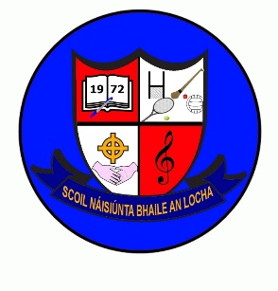
May Newsletter 2023
As we approach the last few weeks of school, I would like to draw your attention to some important dates.
Testing: May 23rd – May 31st Drumcondra Tests will take place.
The above tests are standardised tests which every school is required to do annually. The results of these tests are sent on to the Department of Education. The results will also be printed on your child’s end of year report card which will be sent out mid-June. Please ensure your child is present at school on the above dates.
Closure: School will close @ 12 on Friday 2nd June for teacher Primary language training.
Bank Holiday: June 5th school closed.
Sponsored walk: Wednesday 14th June (weather permitting) sponsorship cards will be sent home this week.
Sports Day: 15th June (all children can wear tracksuits on this day, more information will follow)
School Tours: Friday 16th June Rockfield House (2nd- 6th class) cost is €30 per pupil.
Friday 16th June Navan Adventure Centre (junior infants – 1st class) cost is €30 per pupil.
Cost includes admission @ €20pp plus bus.
Tours are payable before Friday 9th June please.
New Infants: Wed 21st June. We will be welcoming our new pupils on this day.
10-12.15 A brief parent/teacher introductory meeting will be held from 12-12.15.
Holidays: Thursday June 22nd @ 12

Congratulations to Ava, Charlotte, Casey, Emily, Ella, Kimberley,Lilybelle, Maia & Porsha who made their First Holy Communion on Saturday. It was a beautiful day. Thank you to all the parents who volunteered to help with the refreshments in the hall and to our Parents Association and to the staff. It is great to have a wonderful supportive school community.

