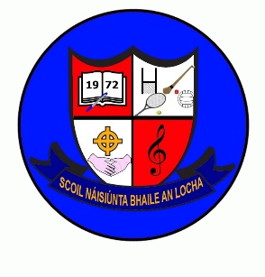
October Newsletter (2) 2023
Retirement
Mrs Reilly’s retirement mass will be held in the church on Wednesday 25th Oct @ 12 noon, with a party in the hall afterwards.
We appreciate parents are working, so we will be opening up the hall to parents between 2pm & 3pm, where you are free to pop in for a cup of tea, take the opportunity to wish Mrs Reilly well in her retirement before collecting your child.
We would be very grateful if you could drop any donations of biscuits, buns, cakes into the school either Tuesday 24th or Wed 25th (morning).

School Fundraiser
Movie Afternoon
When: Tuesday 24th October
Children will remain in school from 2.40 until 4pm. There will be a Junior film and a Senior film supervised by teachers. Cost is €5 per child and capped at €10 for families. The proceeds are going towards a new interactive whiteboard for the Junior room. Children are free to bring in treats and snacks on this day.

Well-being Week
Is being held the week of the 23rd October up to 27th October. Please see attached for activities.

Homework will be from a Choice Board of family activities. No written homework for this week. Life can be very busy for adults and pupils alike with very little quality family time. This week is about spending time together and having fun as a family, whether that’s making a jigsaw or going on an autumnal walk.
School Fees
Reminder: School fees if you haven’t paid them already are due by Friday 27th October.

B.O.M Nominees
Balloting sheets will be distributed this week. Please return by Mon 23rd October.

