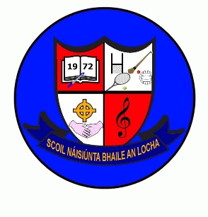
October Newsletter
Parents Association:
We wish to thank the outgoing Parents Association – Aideen Stanley, Caroline Mulvaney & Laura Burke for their time and commitment to the role for the past two years. Votes will be counted this week to elect a new Parents Association.
B.O.M:
Our Board of Managements term has also come to an end (2019-2023) A new B.O.M will take over on 1st December2023. Consent forms for nominations for Parent nominees will be distributed this week ahead of Balloting later this month. We would be grateful if you could return the consent form as soon as possible so balloting list can be prepared.
Retirement:
As you are aware Mrs Reilly is retiring this month. Her last day at school will be 27th October. It is her wish to have a very simple celebration to mark her retirement. A school mass for pupils and staff on Wednesday 25th October. After this mass, we hope to have a party back at school.
Uniform:
Reminder – shorts and t-shirt are only permitted as part of the uniform for the summer months only.
Music:
Music lessons commence with Harry Long this Thursday.
Visitors:
Nicola Walsh from Road Safety Ireland visited the pupils for a talk on road safety. Representatives from Eureka & St. Ciaran’s visited 5th & 6th class pupils to talk about transitioning to Secondary school.
P.T meetings:
We have had to change the date for our Parent Teacher meetings to Wednesday 18th October (2.45-5pm) Teachers will be in touch to arrange appointments. If you cannot make the 18th October, please get in touch with your child’s teacher to re-schedule an appointment.
Wellbeing Week:
Will be held in school Mon 23rd- Fri 27th October. We will be in touch nearer the time for a schedule of events.
Halloween Holidays:
Fri 27th (full school day) children are free to wear Halloween costumes on this day if they do so wish.

